Getting Started with Java
Objectives
- Introduction To Java
- Need for Java
- Features of Java
- Evolution of Java
- Identify Real World Application
Introduction to Java
Java is an object-oriented programming language developed by Sun
Microsystems. Modeled on C++, Java was designed to be small, simple, and portable across platforms. The creator of Java is Sun Microsystems’ chief programmer, James Gosling. He and his team started a project to create software for controlling electronic devices.

Need for Java
Java was developed to solve one of the biggest challenges in software development: creating applications that can run on different operating systems without modification. Its principle of "Write Once, Run Anywhere (WORA)" made it a revolutionary programming language.
Today, Java remains one of the most widely used technologies for enterprise applications, cloud computing, mobile development, banking systems, and large-scale web applications.
Java Features
The primary goals behind Java's development were:
- Platform Independence – Run applications on Windows, Linux, macOS, and other platforms without recompilation.
- Portability – Easily move applications across different environments.
- Security – Provide a secure execution environment.
- Reliability – Reduce programming errors through strong type checking and exception handling.
- Network-Centric Development – Support distributed and internet-based applications.
- Object-Oriented Design – Promote code reusability and maintainability.

Java Evolution
Java was originally developed by Sun Microsystems to program electronic devices, not for Internet applications. The goal was to create a simple, portable, and platform-independent language that could run on different devices and operating systems.
A team led by James Gosling developed a new language based on the concepts of C++. Initially named Oak, it was later renamed Java. As the Internet grew rapidly, Java's built-in features such as portability, networking, security, and distributed computing made it ideal for web-based applications.
Today, Java is widely used for enterprise applications, web development, Android development, cloud computing, microservices, big data, and financial systems.

Timeline of Java Evolution
Year | Development
1990 | Sun Microsystems started a project for programming electronic devices.
1991 | A new language called Oak was developed based on C++ concepts.
1993 | The World Wide Web (WWW) became popular, increasing the demand for Internet-based applications.
1994 | Sun developed HotJava, a web browser capable of running Java applets.
1995 | Oak was renamed Java and officially launched.
1996 | Java became a widely accepted Object-Oriented Programming (OOP) language.
2006 | Java became open-source under the OpenJDK project.
2010 | Oracle Corporation acquired Sun Microsystems and became the steward of Java.
2014-today | Java evolved with modern features such as Lambda Expressions, Streams, Modules, Records, Pattern Matching, Virtual Threads, and Cloud-Native development support.  30. import React, { useState, useEffect } from 'react'; const Counter = () => { const [count, setCount] = useState(0); useEffect(() => { document.title = `Count: ${count}`; }, [count]); const incrementCount = () => { setCount(count + 1); }; return (  Count: {count}  Increment  ); }; export default Counter; What effect does the useEffect hook have in this component?Attempted1/1  It updates the document title with the current count whenever the component mounts.  It updates the document title with the current count whenever the count state changes.  It increments the count state by 1 every time the component renders.  It increments the count state by 1 every time the Increment button is clicked.

Different Editions of Java
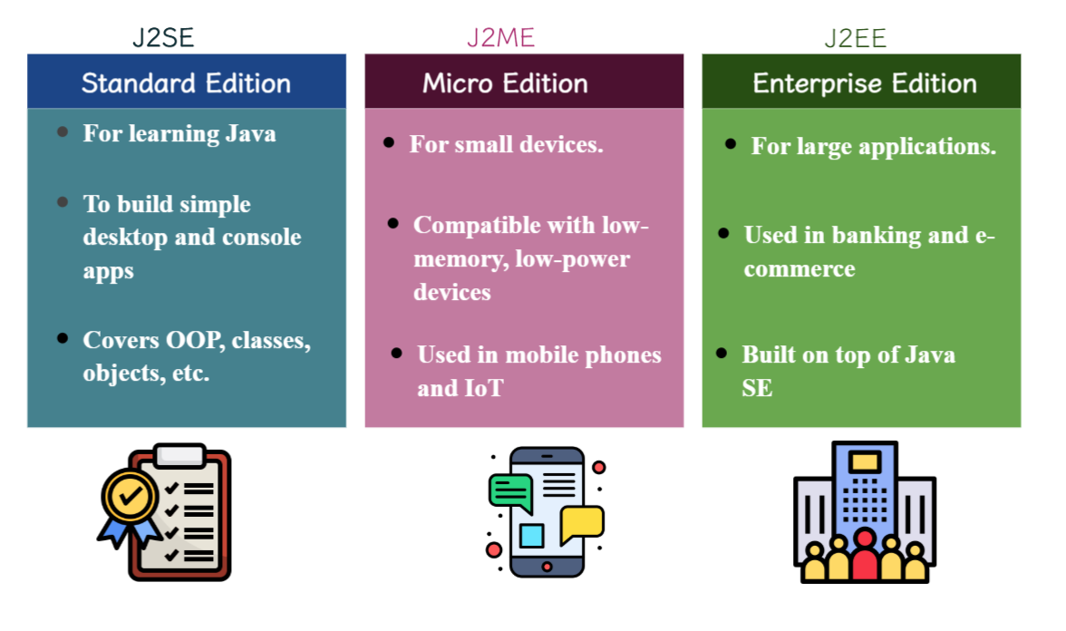

Applications of Java
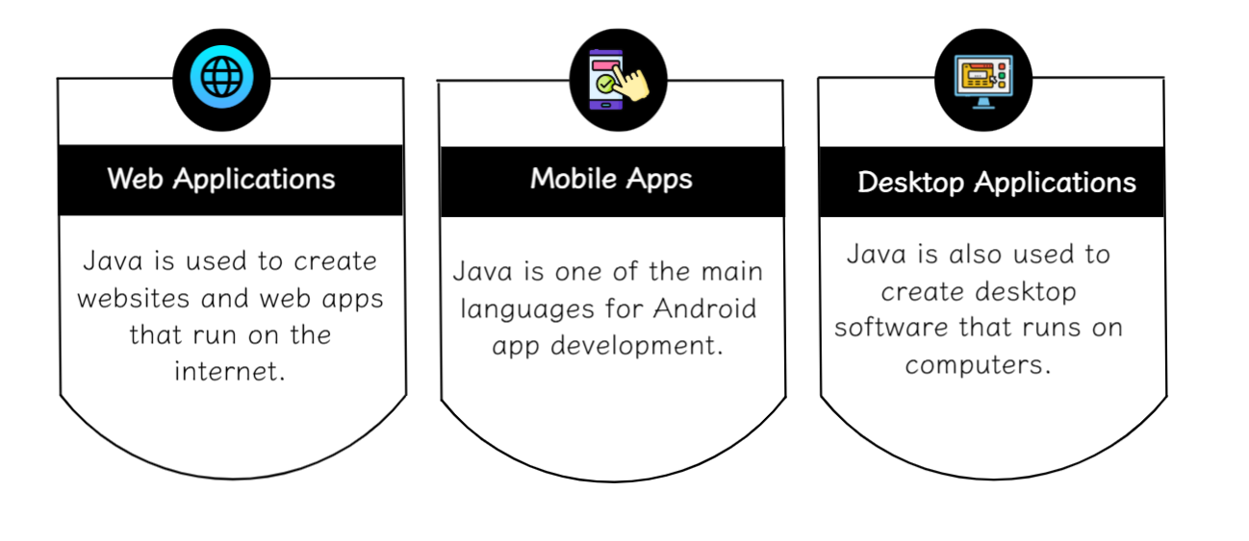

Comparison of Java with Other Languages like C++ & Python
